WEEK-4(23BD1A05B3 )
Simple Storage Service (S3)
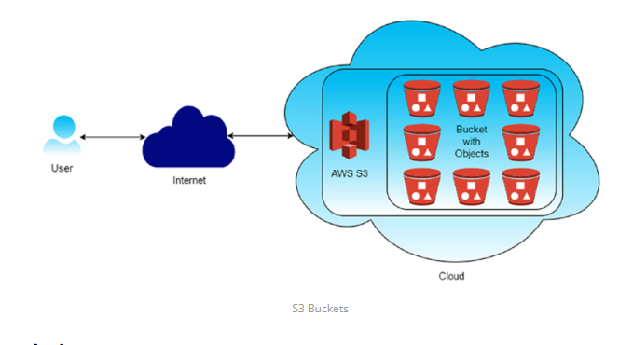1. Versioning: Versioning in Amazon S3 is a feature that allows you to keep multiple versions of an object in the same bucket. Whenever you upload a new version of an object with the same key (name) as an existing object, S3 doesn't overwrite the existing object but instead creates a new version of it. This means you can retain and access previous versions of objects, providing an additional layer of protection against accidental deletions or overwrites
- Accidental Deletion Protection :: With versioning enabled, if you accidentally delete an object, you can still retrieve previous versions of it, preventing data loss.
- Accidental Overwrite Protection::Versioning prevents accidental overwrites of objects. Even if you upload a new version of an object with the same name, the previous versions are preserved.
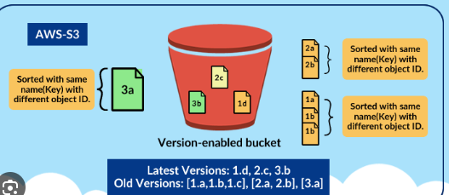
- Cross-Region Replication: Cross-region replication (CRR) in Amazon S3 is a feature that automatically replicates objects from one bucket in one AWS region to another bucket in a different AWS region. This provides redundancy and disaster recovery capabilities, ensuring that your data remains available even if an entire AWS region becomes unavailable.
- Disaster Recovery: Cross-region replication helps ensure business continuity by replicating critical data to a different geographic region, reducing the risk of data loss due to regional disasters or outages.
- Low-Latency Access: Users in different geographic regions can access data from the nearest region, reducing latency and improving performance.
- Compliance: Some regulatory requirements mandate data replication across multiple geographic regions for data sovereignty and compliance reasons.
- Event Notifications: S3 can trigger events (e.g., object creation, deletion) that can be routed to AWS Lambda, SNS, or SQS for processing.
- Integration: S3 seamlessly integrates with other AWS services such as AWS Lambda, Amazon CloudFront, AWS Glue, Amazon Athena, and Amazon EMR, enabling you to build powerful data processing and analytics workflows.

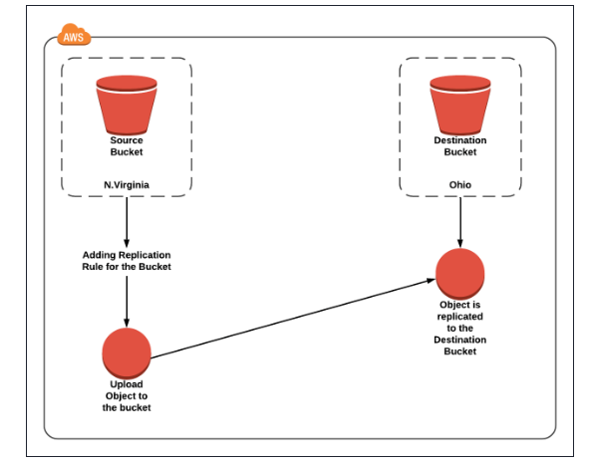

1.Creating an S3 bucket, upload an object, and enable public access
1.Create an S3 Bucket (with Public Access Enabled)
Step 1: Open S3 Service
- Login to AWS Management Console
- Go to Services → S3
- Click Create bucket
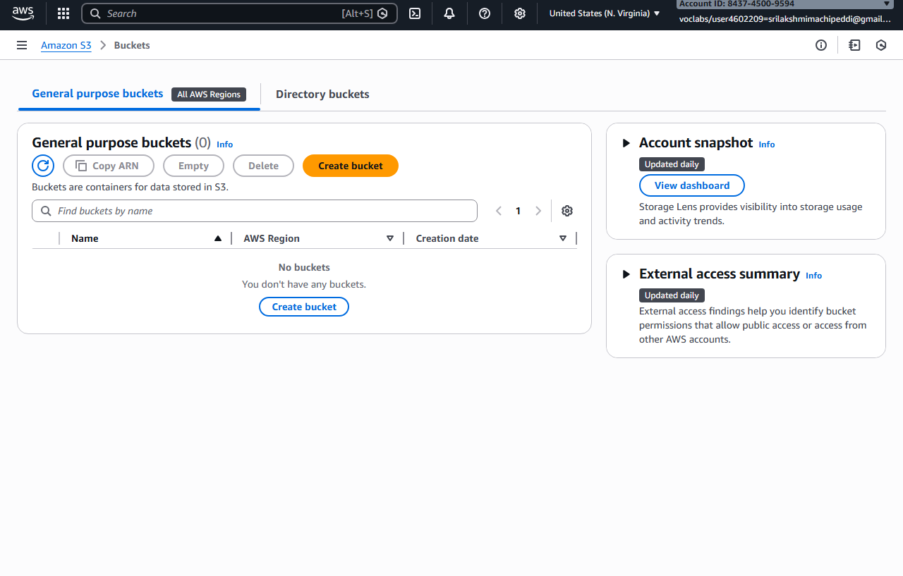

Step 2: Bucket Configuration
- Bucket name: my-public-bucket-123
- Region: Choose nearest region

Step 3: Disable Block Public Access (IMPORTANT)
Under Block Public Access settings for this bucket:
❌Uncheck Block all public access
You must uncheck ALL options:
✔ Check I acknowledge that this bucket will become public
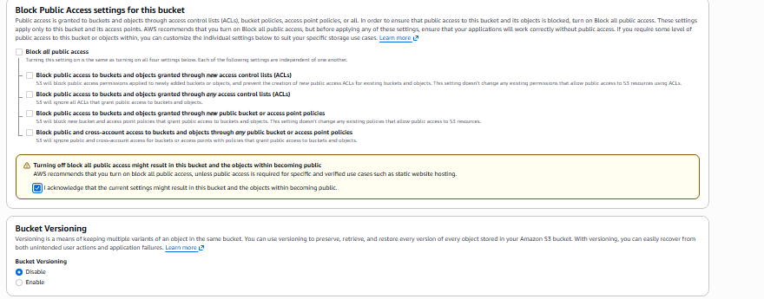
👉 Click Create bucket

2.Enable Public Access at Bucket Level (ACL)
Step 4: Open the Bucket
- Click on the bucket name
- Go to Permissions tab

Step 5: Edit Bucket ACL
- Scroll to Access Control List (ACL)
- Click Edit
Under Public access:
- Everyone (public access) → ✔ Read access
✔ Save changes
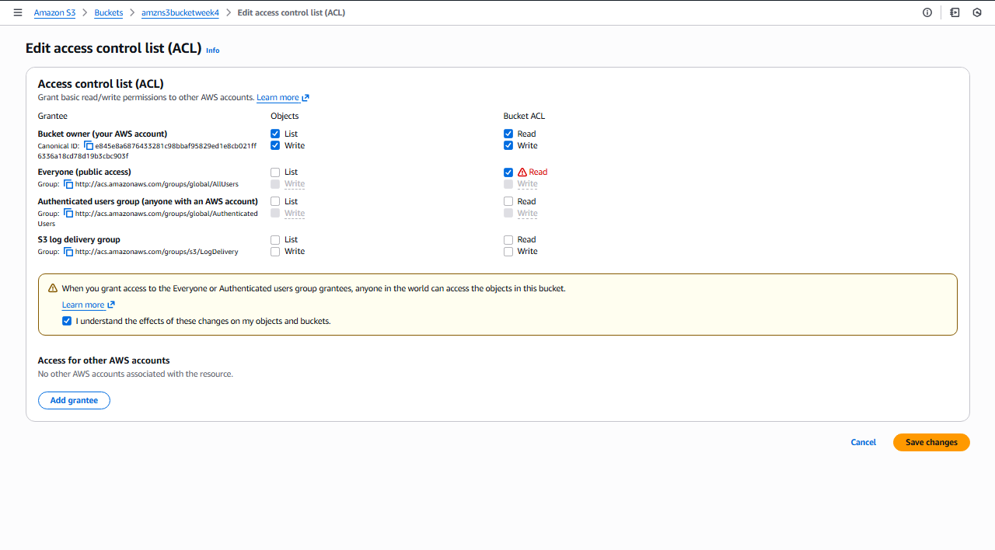
📌 This allows public access at bucket level

3.Upload Object to the Bucket
Step 6: Upload File
- Go to Objects tab
- Click Upload
- Click Add files
- Select file (e.g., image.jpg)
- Click Upload

4.Enable Public Access for Object (ACL)
Step 7: Object-Level ACL Permission
- Click on uploaded object
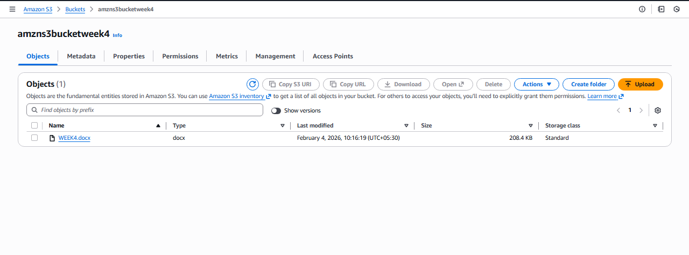
- Go to Permissions tab
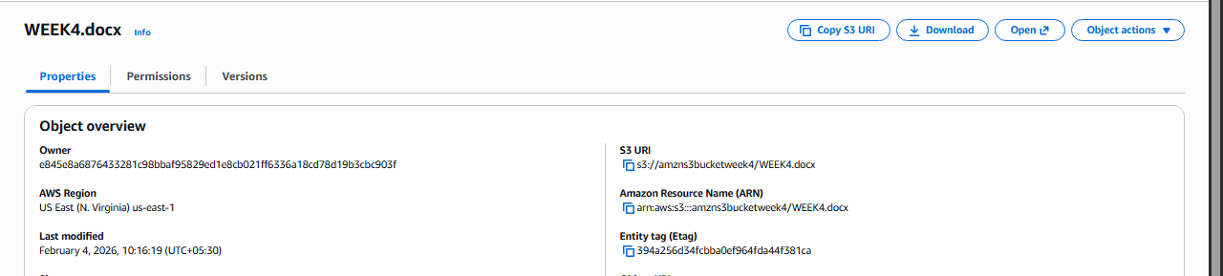
- Scroll to Access Control List (ACL)
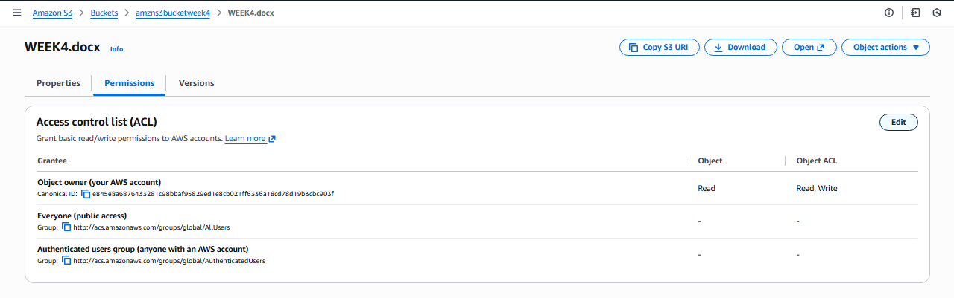
- Click Edit
Under Public access:
- Everyone (public access) → ✔ Read access
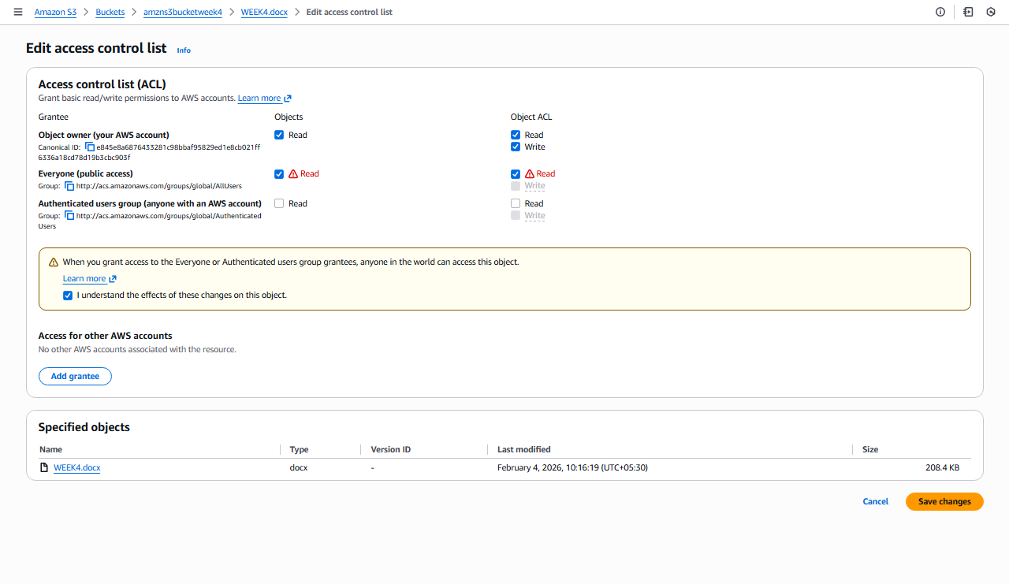
✔ Save changes

5.Verify Public Access
Step 8: Test Object URL
- Copy Object URL
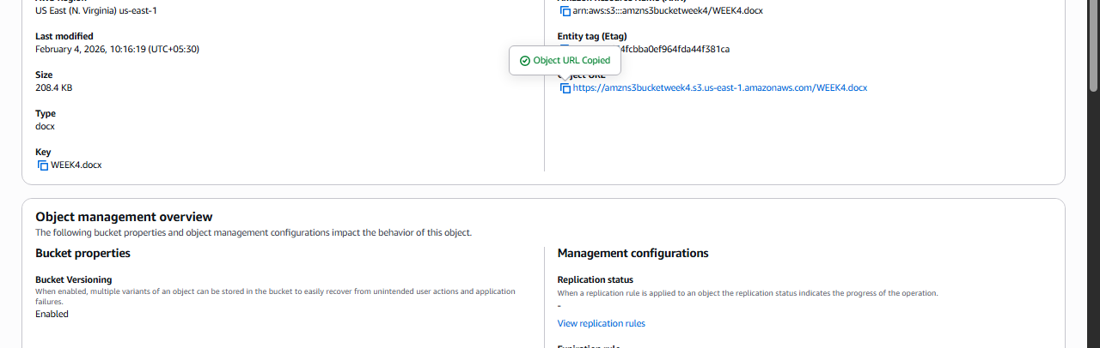
- Open in browser (incognito)
✔ Object should be accessible without login
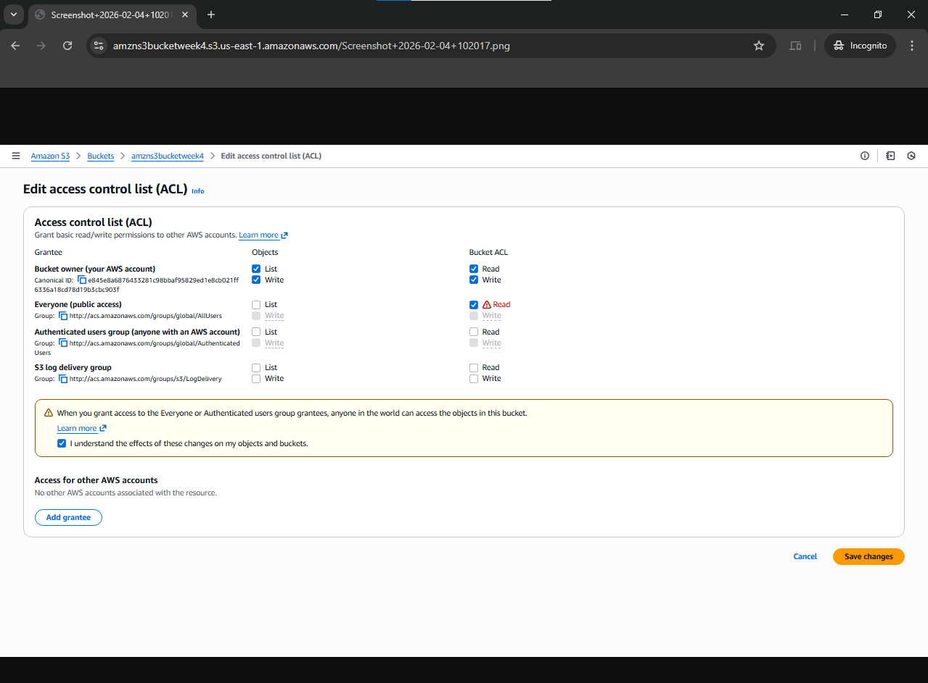

2. S3 Versioning & Cross-Region Replication

1.Enabling Versioning in S3 (with Output Scenario)
🔸 Objective
To enable version control on an S3 bucket and observe object versions.

🔸 Steps to Enable Versioning
- Open AWS Management Console
- Navigate to S3
- Select the bucket
- Go to Properties tab
- Scroll to Bucket Versioning
- Click Edit
- Select Enable
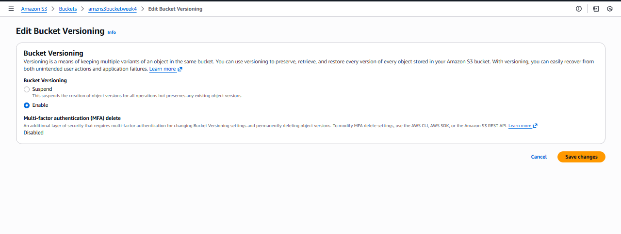
- Click Save changes
✔ Versioning is now enabled

🔸 Output Scenario (What You Observe)
Step A: Upload Object
- Upload file: report.pdf
📌 Output:
- Version ID is assigned automatically
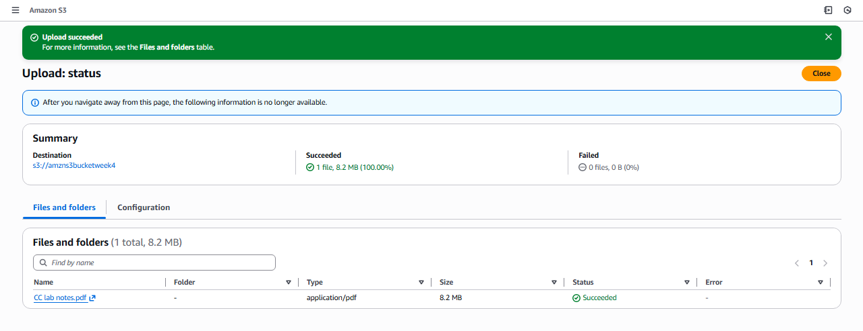

Step B: Modify and Re-upload Same Object
- Upload report.pdf again (same name)

📌Output:
- Old version is preserved
- New version becomes current
- 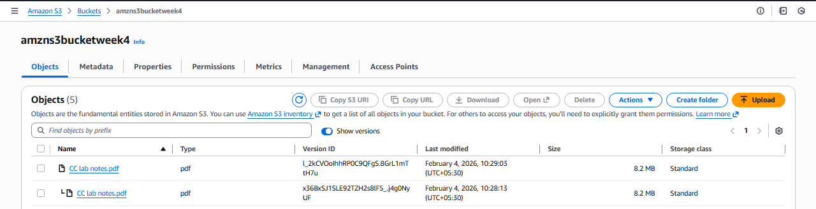

Step C: Delete Object
- Click Delete on report.pdf
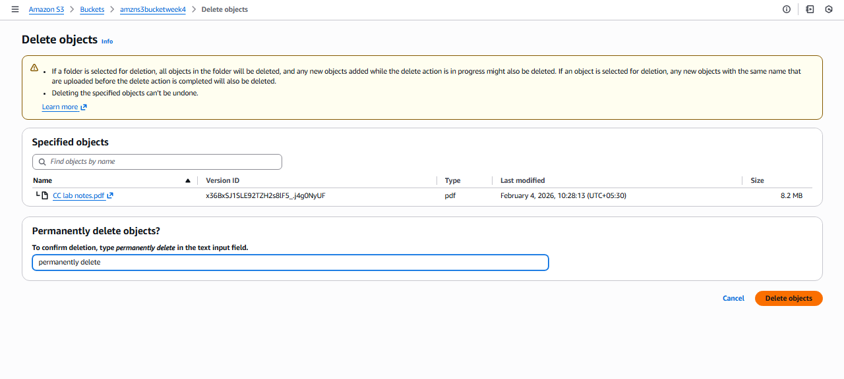
📌 Output:
- Object appears deleted
- A Delete Marker is created
- Older versions still exist and can be restored

2.Cross-Region Replication (CRR)
🔸 Objective
To replicate objects from one bucket to another in a different region using AWS-managed permissions.

🔸 Prerequisites (Very Important)
✔Versioning must be enabled on both buckets
✔ Source and destination buckets must be in different regions
✔ AWS Academy automatically handles replication permissions

Step 1.Create Destination Bucket
- Go to S3 → Create bucket
- Bucket name: dest-crr-bucket
- Select different region
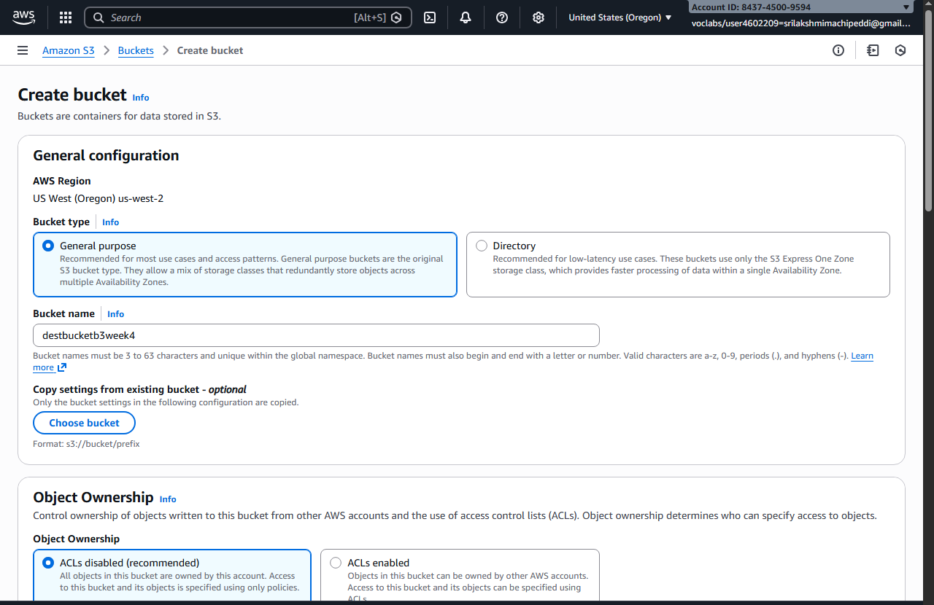
- Complete bucket creation
- Enable Versioning (same steps as above)
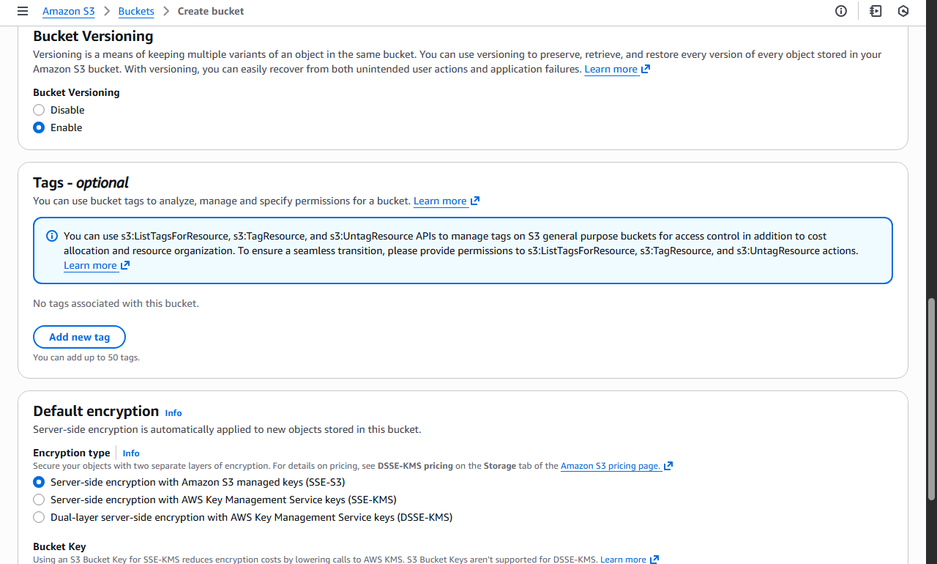

Step 2.Create Replication Rule (Without IAM Selection)
- Open Source bucket
- Go to Management tab
- Click Replication rules
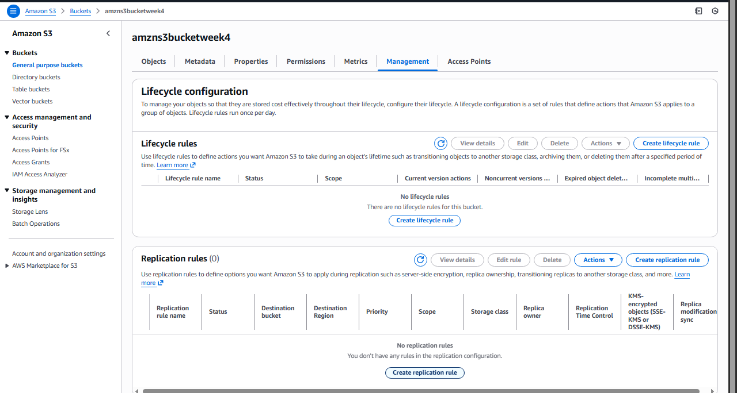
- Click Create replication rule

Step 3.Configure Replication Rule
- Rule name: academy-crr-rule
- Status: Enabled
- Scope: Apply to all objects
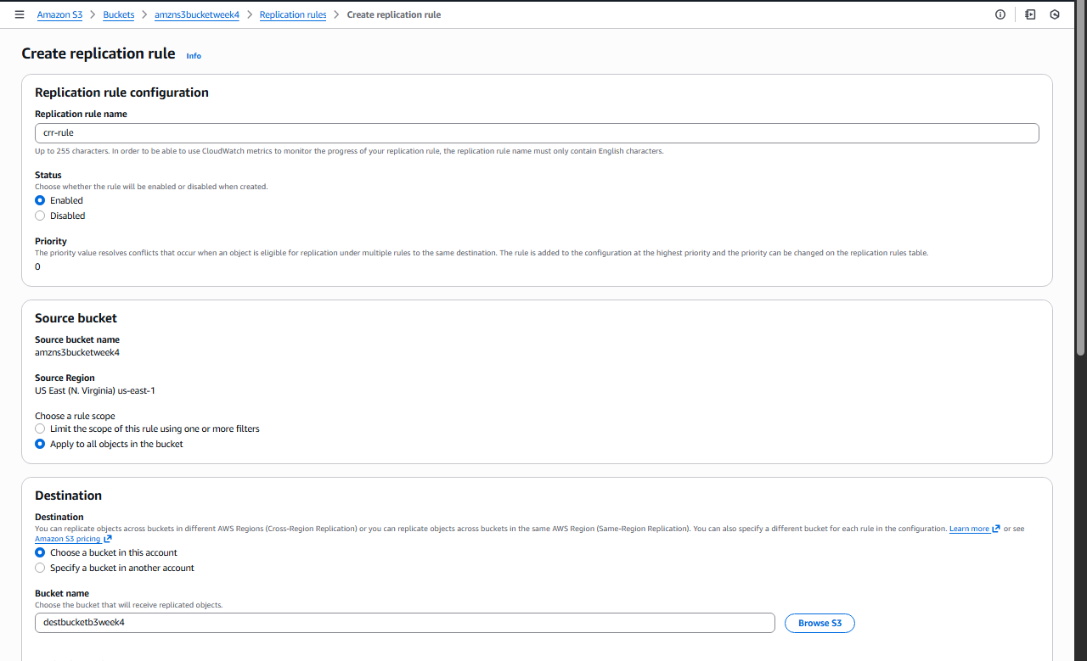

Step 4.Choose Destination Bucket
- Select Another bucket
- Choose Destination bucket
- Confirm different region
📌 AWS Academy Note:
You will see an option like:
"AWS will create and manage the required permissions automatically"
✔ Select Use AWS-managed role / default role

Step 5.Replication Options
- Replicate:
  - ✔ New objects
  - ❌ Existing objects (optional, depends on Academy permissions)
- Encryption: Leave default
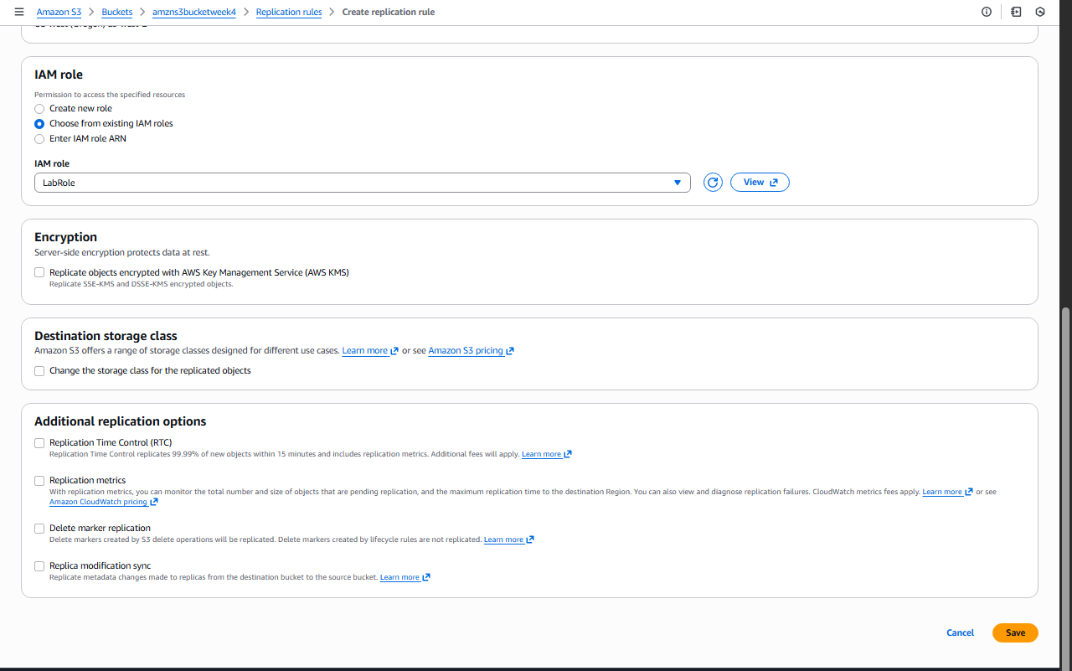
Click Save
✔ Replication rule is now active
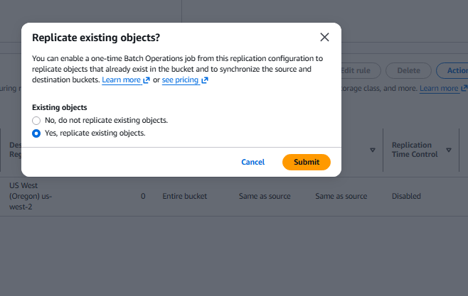
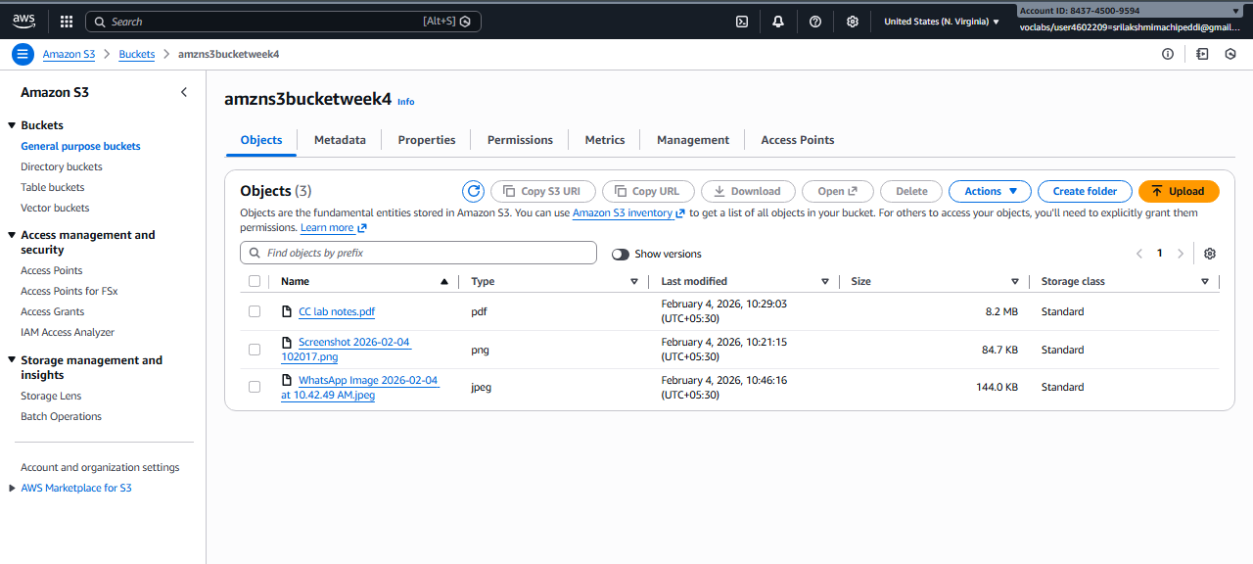

3.CRR Output Scenario (What You Observe)
🔸Step A: Upload New Object to Source Bucket
- Upload file: image.png
📌 Output:
- Object is uploaded normally
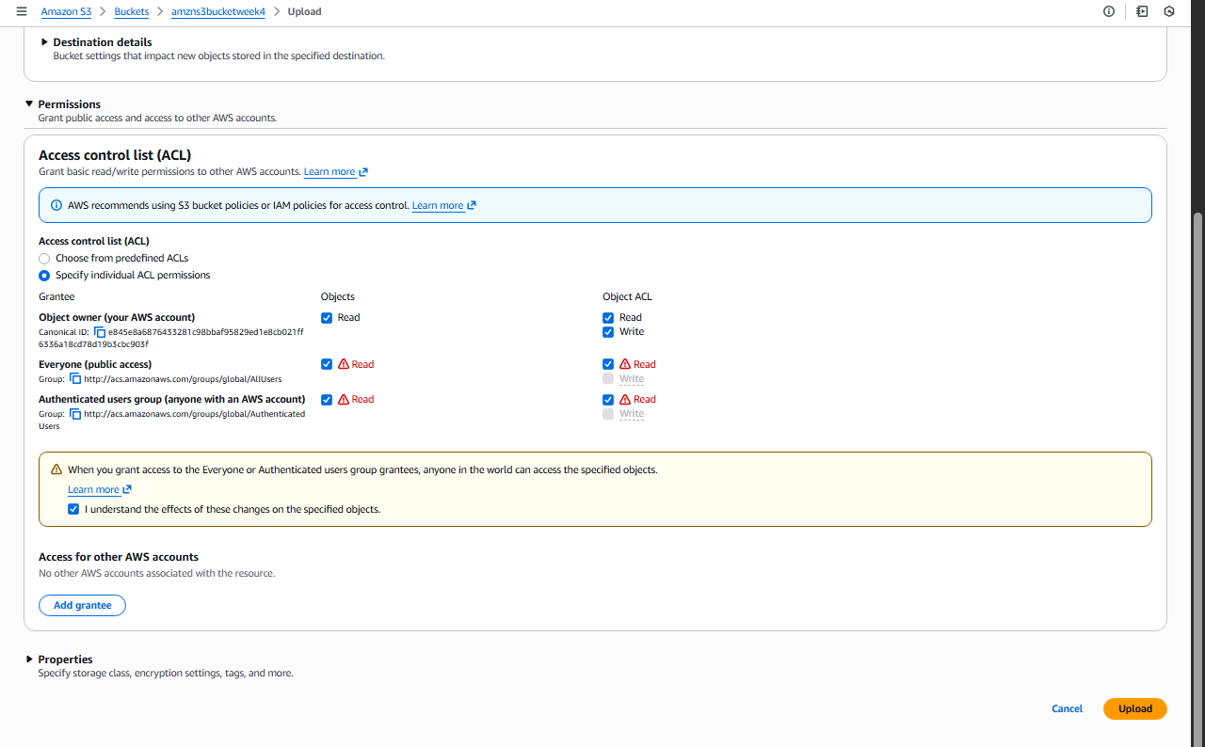

🔸 Step B: Verify Destination Bucket
- Open destination bucket
- Object image.png appears automatically
- Version ID is present
✔ Replication successful
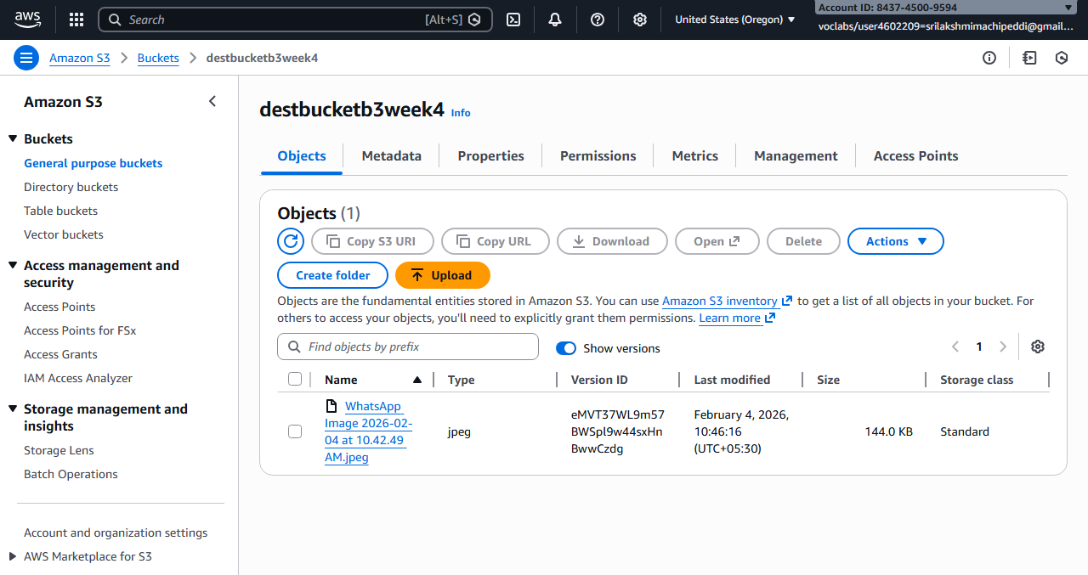

  - Static Website Hosting in S3
(Using Bucket-Level & Object-Level Permissions – ACL Method)

🔹 Objective
To host a static website in Amazon S3 using index.html and error.html, and allow public access using ACL-based bucket and object permissions.

🔹 Prerequisites
- AWS / AWS Academy account
- Two files:
  - index.html
  - error.html

1.Create an S3 Bucket
- Login to AWS Management Console
- Go to Services → S3
- Click Create bucket
- Enter:
  - Bucket name: my-static-site-bucket-123
  - Region: Nearest region
- Under Block Public Access:
  - ❌ Uncheck Block all public access
  - ✔ Acknowledge the warning
- Click Create bucket
✔ Bucket created successfully
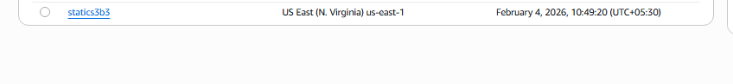

2.Upload Website Files
- Open the bucket
- Go to Objects tab
- Click Upload
- Click Add files
- Select:
  - index.html
  - error.html
- Click Upload
✔ Files uploaded
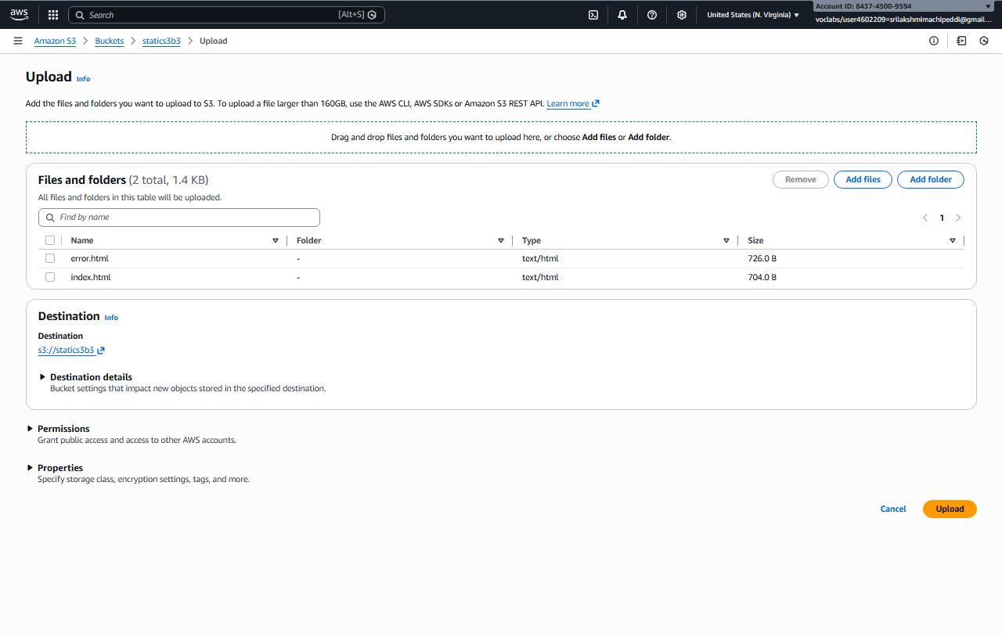

3.Enable Static Website Hosting
- Go to Properties tab
- Scroll to Static website hosting
- Click Edit
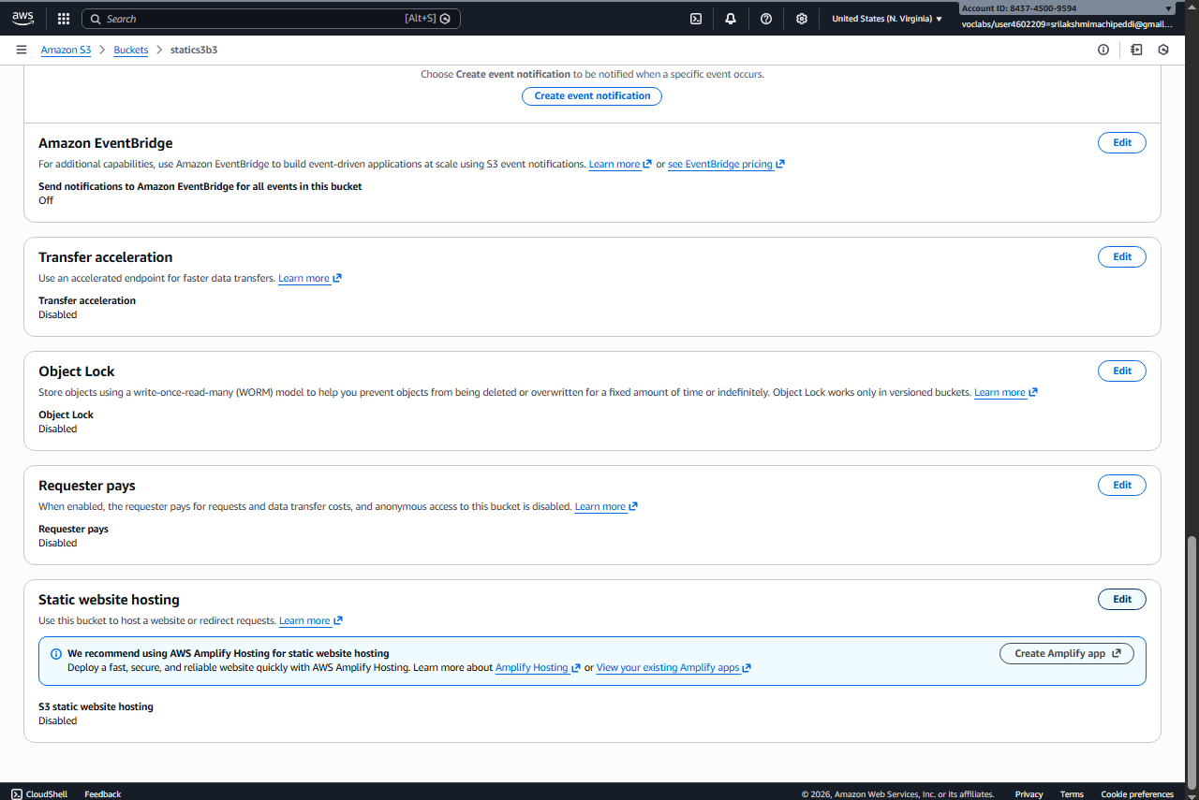
- Select Enable
- Choose Host a static website
- Enter:
  - Index document: index.html
  - Error document: error.html
- Click Save changes
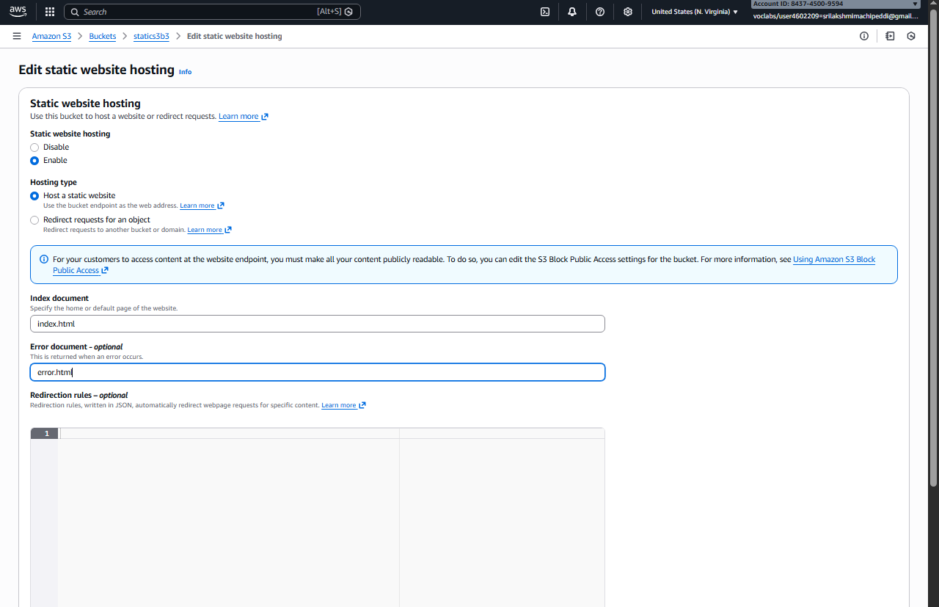
✔ Static website hosting enabled

4.Enable Bucket-Level Public Access (ACL)
🔹 Purpose
Allows public users to access objects inside the bucket.

- Go to Permissions tab
- Scroll to Access Control List (ACL)
- Click Edit
- Under Public access:
  - Everyone (public access) → ✔ Read
- Click Save changes
✔ Bucket-level public read access enabled

5.Enable Object-Level Public Access (ACL)
Steps (For Each File)
- Go to Objects tab
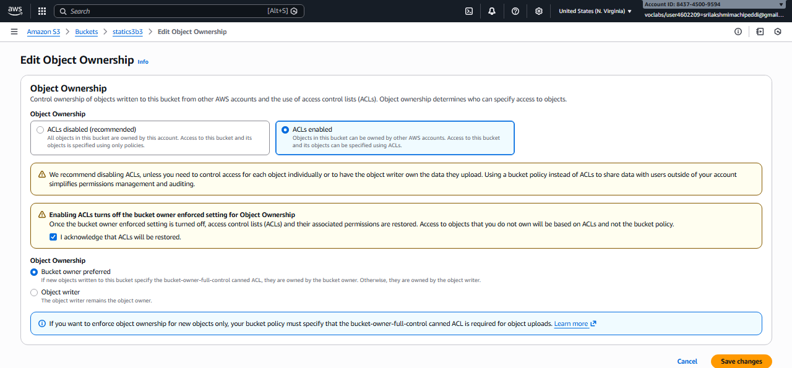
- Click on index.html
- Go to Permissions
- Scroll to Access Control List (ACL)
- Click Edit
- Under Public access:
  - Everyone (public access) → ✔ Read
- Save changes
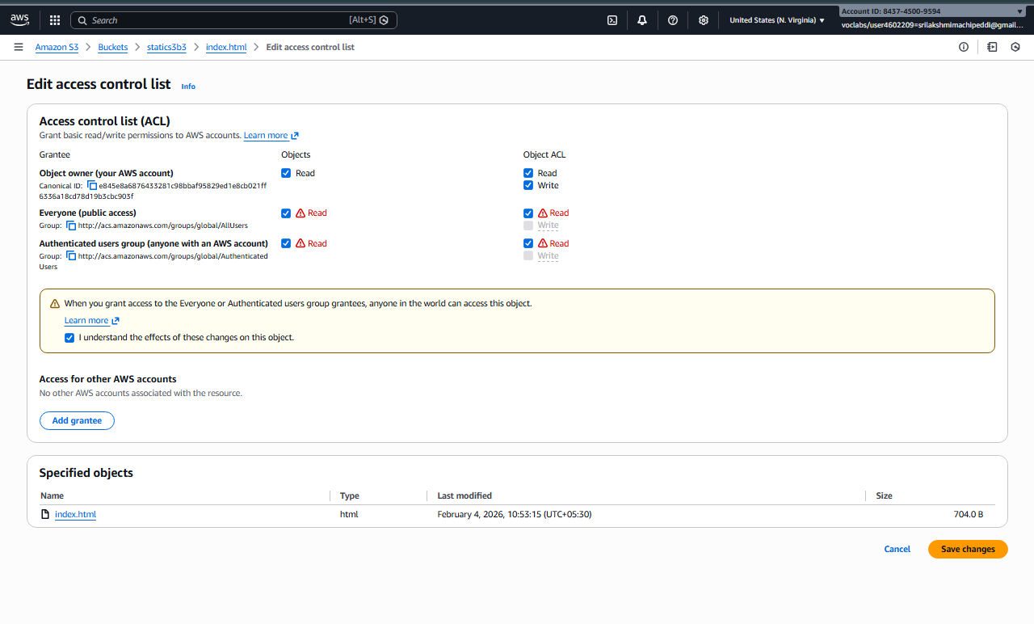
🔁 Repeat the same steps for error.html
✔ Object-level public access enabled
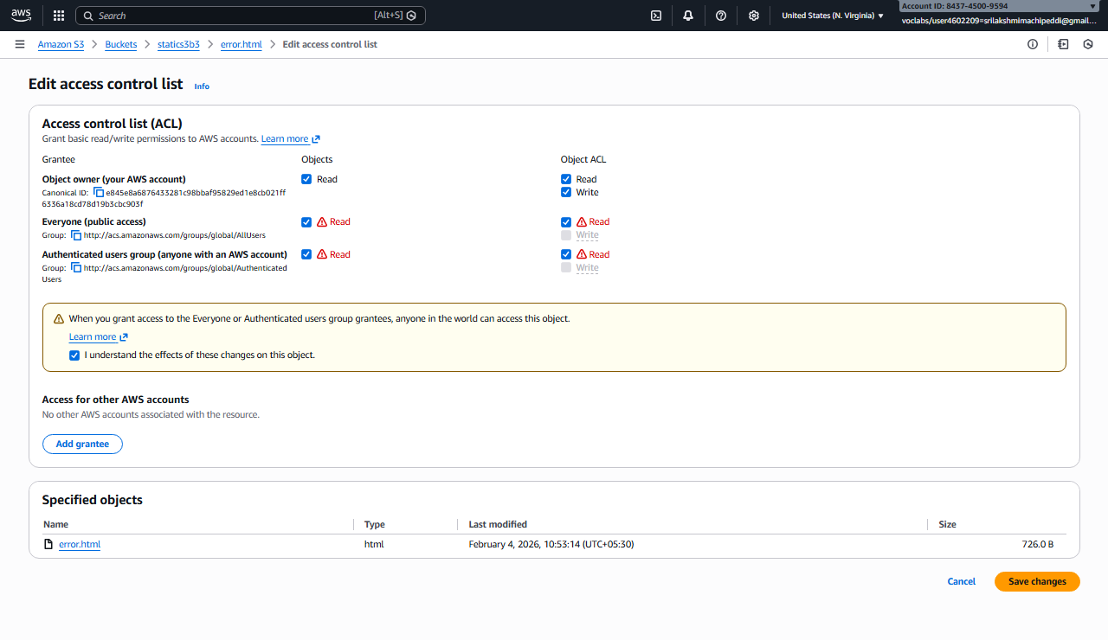

6.Access the Static Website
- Go to Properties
- Scroll to Static website hosting
- Copy the Bucket website endpoint
- http://my-static-site-bucket-123.s3-website-region.amazonaws.com
- Paste into browser
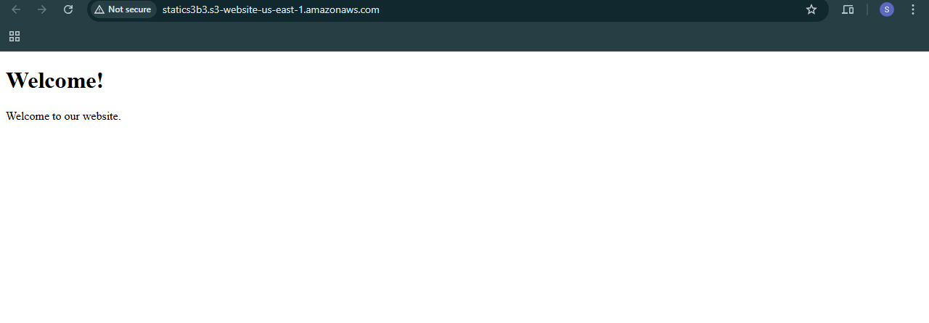
✔ index.html page loads successfully

7.Error Page Output Scenario
🔹Test Error Page
- Open an invalid URL:
- http://bucket-name.s3-website-region.amazonaws.com/invalid.html
📌 Output:
- error.html page is displayed
✔ Error page working correctly
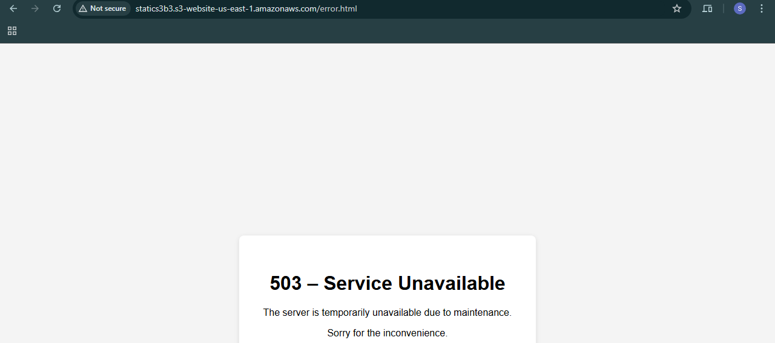

Scenario-Based Questions

EC-2
- You are launching a Linux EC2 instance for the first time. AWS asks you to select a key pair.
Why is a key pair mandatory, and what will happen if you skip it?
A key pair is required for SSH authentication; skipping it makes the instance inaccessible.
- You created an EC2 instance, but SSH connection times out from your local machine.
What security group–related issues would you check first?
Check if inbound rule allows port 22 from your IP address.
- You want to allow only your office IP to connect to EC2 via SSH.
How would you configure the security group, and why is this important?
Allow port 22 only from the office public IP to restrict unauthorized access.
- You launched a Windows EC2 instance and want to connect using RDP.
Which port must be opened, and why should it not be open to 0.0.0.0/0?
Port 3389 must be opened; opening it publicly increases security risk.
- You are working on a Windows laptop and want to connect to a Linux EC2 instance using PuTTY.
Why do you need to convert a .pem file to .ppk?
PuTTY requires .ppk format for authentication.
- A Linux EC2 instance was launched using an Amazon Linux AMI.
What does an AMI contain, and how does it affect instance behavior?
An AMI contains OS, packages, and configuration that define instance setup.
- You need to create multiple identical EC2 instances with the same software installed.
Create a custom AMI and launch instances from it.
- You want to connect to EC2 but cannot use your local machine due to corporate restrictions.
Use AWS CloudShell or another EC2 as a bastion host.
- You accidentally deleted the inbound SSH rule from a security group. What immediate impact will this have on existing EC2 connections?
New SSH connections fail while existing sessions may continue.
- You are creating a production EC2 instance. Why should you avoid using the default security group?
Default security group lacks least-privilege controls.
- A Windows EC2 instance is running, but RDP login fails even though the instance is healthy.
What key pair–related or configuration issues could cause this?
Incorrect key pair, password not decrypted, or RDP port blocked.
- You want to automate EC2 creation using the same OS, disk size, and software stack.
Which EC2 component helps you standardize this setup?
Use a custom AMI or Launch Template.
- You launched an EC2 instance using the wrong AMI (Windows instead of Linux).
Can you change the AMI after launch? What would you do instead?
AMI cannot be changed; launch a new instance with correct AMI.
- You created a security group allowing SSH from anywhere for testing.
Why is this dangerous in production, and how would you fix it?
It exposes the instance publicly; restrict SSH to trusted IPs.
- How do you to migrate an EC2 setup from one region to another.
Create an AMI and copy it to the target region.

EBS
- a) Create and attach an EBS volume to an EC2 instance, and
b) scale the instance by increasing CPU and RAM by changing the instance type.
a) Create, attach, and mount the volume; b) stop instance and change instance type.
- Attach and permanently mount an EBS volume to a Linux EC2 instance to ensure data persistence across reboots.
Mount the volume and add entry in /etc/fstab.
- Create a snapshot of the attached EBS volume and use it to create and attach a new volume to an EC2 instance in another AWS region.
Copy snapshot to another region and create a volume from it.

SENARIO BASED QUESTIONS
- A production database running on EC2 is facing high IOPS latency. Which EBS volume type would you migrate to and why?
Use io2 for high and consistent IOPS.
- You are hosting a boot volume for an EC2 instance used only for testing. Which EBS volume type is most cost-effective?
gp3 or gp2.
- An analytics application requires high throughput for large sequential reads. Which EBS volume type should be chosen?
st1.
- Your application workload is unpredictable and needs burst performance occasionally. Which EBS volume fits?
gp3 or gp2.
- You attached an st1 volume to a database server and performance dropped. Why?
st1 is not optimized for random IOPS.
- How do you identify which volume is mounted to /data?
Use lsblk or df -h.
- After reboot, application fails because volume is missing. Why?
Volume was not configured in fstab.
- Why does manual mount disappear after reboot?
Manual mounts are not persistent.
- How do you auto-mount after reboot?
Add correct entry in /etc/fstab.
- Wrong fstab entry caused emergency mode. What mistake?
Incorrect UUID or mount options.
- EC2 terminated but data volume exists. Why?
Delete on termination was disabled.
- Root volume deleted automatically. Why?
Delete on termination was enabled.
- How to protect data from accidental EC2 deletion?
Disable delete on termination and take snapshots.
- What happens when EBS is detached?
Data remains intact on the volume.
- EC2 crashed. How do you restore?
Attach the volume to another instance or restore from snapshot.
- Can you create a volume from snapshot while EC2 is running?
Yes.
- How does EBS help in DR across regions?
Snapshots can be copied to other regions.
- Can EBS be attached across regions?
No, EBS is region-specific.
- What to use for shared storage?
Use EFS.
- How to share snapshot with another account?
Modify snapshot permissions.

Elastic File Storage

Scenario-Based Questions on Amazon EFS
- Multiple EC2 instances across different Availability Zones must read and write the same files at the same time. Which AWS storage service fits this requirement and why?
EFS because it supports concurrent access.
- An application running on EC2 in three different AZs needs a shared file system with low operational overhead. How would EFS support this setup?
EFS is regional and automatically scales across AZs.
- You mounted an EFS file system on one EC2 instance. Can another EC2 instance modify the same file simultaneously? What happens in such a scenario?
Yes, NFS handles file locking.
- Your team tried to attach an EFS file system to an EC2 instance, but the mount command timed out. What networking components would you check first?
Security groups, NACLs, and mount targets.
- An EC2 instance in a private subnet is unable to mount EFS. What configuration might be missing at the subnet or VPC level?
Missing route or DNS resolution.
- You created an EFS file system but forgot to create mount targets in all AZs. How will this affect EC2 instances in those AZs?
They cannot mount EFS locally.
- Why does EFS require mount targets in each Availability Zone, and what happens if one AZ goes down?
For low latency; other AZs continue access.
- Two applications in different subnets need access to the same EFS file system. How should the EFS networking and security groups be configured?
Allow NFS port 2049 between security groups.
- Your security team wants only specific EC2 instances to access EFS. How can security groups be used to enforce this?
Allow inbound NFS only from specific EC2 security groups.
- While mounting EFS, the command specifies -t nfs4. Why does EFS use NFS, and what advantage does it provide?
NFS allows shared and scalable file access.
- An organization wants to migrate from EBS to EFS because multiple EC2 instances need concurrent access to data. What limitation of EBS is driving this decision?
EBS cannot be shared across multiple instances.
- An application team complains about increased latency when accessing EFS from EC2. What factors related to networking or AZ placement should be considered?
Cross-AZ access and network bandwidth.
- Can an EFS file system be accessed from EC2 instances in different VPCs? If yes, what networking setup is required?
Yes, using VPC peering or Transit Gateway.

Amazon S3
Scenario-Based Questions
- A developer uploads an object to an S3 bucket but cannot access it from the browser, even though the bucket exists. What permission-related issue could be the cause?
The object may not have the correct permissions set for public access, or the bucket may have a policy or IAM permissions that prevent public access. The developer may not have the necessary IAM permissions (like s3:GetObject) to access the object. You should check both the bucket policy and the object's ACL (Access Control List).
- An S3 bucket policy allows public read access, but a specific object inside the bucket is still not accessible. Why might this happen?
The object itself might have its own restrictive ACL that overrides the bucket policy. If the object has a private ACL, it can block public access even if the bucket policy allows it. You need to ensure that the object’s ACL allows public read access.
- A bucket has no bucket policy, but individual objects have public ACLs. Will users be able to access those objects? What determines the final access decision?
Yes, users will be able to access the objects if the objects have public ACLs. However, this is subject to the Block Public Access settings for the bucket or account, which could prevent public access despite the object's ACL settings. The final access decision is influenced by bucket-wide settings, object ACLs, and the Block Public Access settings.

- A company wants to ensure no public access to any object in an S3 bucket, even if someone mistakenly applies a public ACL. What S3 feature should be enabled?
Enable "Block Public Access" at the bucket or account level. This setting ensures that no public access can be granted, even if a user attempts to apply a public ACL to an object.
- You attempt to create an S3 bucket named my-company-data but receive a naming error. What S3 bucket naming rules might have been violated?
Bucket names must be globally unique across all AWS accounts.
Bucket names must be between 3 and 63 characters.
Bucket names can only contain lowercase letters, numbers, hyphens, and periods.
Bucket names cannot contain underscores or start or end with hyphens.
Bucket names cannot have consecutive periods.

- Two different AWS accounts try to create a bucket named project-backup-2026. One succeeds, the other fails. Why?
Bucket names must be globally unique across all AWS accounts. Since one account has already created the bucket with that name, the other account cannot use it. Only the first account succeeds.
- You enabled static website hosting on an S3 bucket and uploaded files, but accessing the website URL returns 403 Forbidden. What is the most likely cause?
Cause: The objects may not have the correct permissions to allow public access. Ensure the objects have an ACL or a bucket policy that allows public read access, and verify that the "Block Public Access" settings are not preventing access.
- Static website hosting is enabled, but accessing the root URL shows an error saying index.html not found. What is the actual issue?
Cause: The index document (index.html) may not be uploaded to the bucket, or it may have been uploaded with incorrect permissions. Make sure the index.html file exists in the root of the bucket and has public read permissions.

- What HTTP error is returned when the index document is missing in S3 static website hosting, and why does this happen?
Error: HTTP 403 Forbidden or HTTP 404 Not Found, depending on the configuration. This happens because S3 cannot find the configured index document to serve as the default homepage for the static website.
- A bucket policy allows public access, but static website hosting still doesn’t work. What object-level setting must also be verified?
Check the object ACLs. Even if the bucket policy allows public access, the objects themselves must also have permissions that allow public read access. The "Block Public Access" settings at the bucket or account level can also prevent public access.
- You accidentally overwrite an important object in S3. Versioning was enabled earlier. How can the original file be recovered?
Solution: You can recover the original object by retrieving the previous version using the S3 console, AWS CLI, or SDKs. The original file is not lost because versioning is enabled; it will exist as an earlier version.
- A user deletes an object from a versioned S3 bucket. Is the data permanently removed? Explain what actually happens.
No, the data is not permanently removed. When an object is deleted from a versioned bucket, S3 creates a delete marker, which makes the object appear deleted. However, the object’s previous versions are still available and can be restored.
- You enabled Cross-Region Replication (CRR) on a bucket, but objects are not replicating. What configuration might be missing?
Solution: Ensure that both source and destination buckets have versioning enabled. Cross-Region Replication requires versioning to be active in both the source and destination buckets.
- After enabling CRR, only newly uploaded objects are replicated, but old objects are not. Why?
Reason: Cross-Region Replication only replicates objects that are uploaded after CRR is enabled. It does not replicate existing objects retroactively. You would need to use a manual process or S3 Batch Operations to replicate older objects.

- A company wants to replicate S3 data to another region for disaster recovery and compliance. What are the key prerequisites for enabling CRR?
Prerequisites:
Versioning must be enabled on both the source and destination buckets.
The destination bucket must be in a different AWS region from the source bucket.
The IAM user must have the necessary permissions to perform replication tasks.
Optionally, the source bucket must be configured with the appropriate replication policy.

